Họ và Tên : Huỳnh Khánh Phong

MSSV : 1150070034

**Lab 2-Bài tập lý thuyết 2**

Layout 1 : RelativeLayout

Activity..xml

<?xml version="1.0" encoding="utf-8"?>  
<RelativeLayout xmlns:android="http://schemas.android.com/apk/res/android"  
 android:layout_width="match_parent"  
 android:layout_height="match_parent"  
 android:paddingStart="16dp"  
 android:paddingEnd="16dp">  
  
 <!-- Tiêu đề đăng nhập -->  
 <TextView  
 android:id="@+id/tv_sign_in"  
 android:layout_width="wrap_content"  
 android:layout_height="wrap_content"  
 android:text="@string/sign_in"  
 android:textAllCaps="true"  
 android:layout_centerHorizontal="true"  
 android:layout_marginTop="@dimen/margin_basex4"  
 android:textSize="@dimen/text_large" />  
  
 <!-- Username label -->  
 <TextView  
 android:id="@+id/tv_user_name"  
 android:layout_width="100dp"  
 android:layout_height="wrap_content"  
 android:text="@string/username"  
 android:layout_below="@id/tv_sign_in"  
 android:layout_marginTop="@dimen/margin_basex4"  
 android:layout_alignParentStart="true" />  
  
 <!-- Username input -->  
 <EditText  
 android:id="@+id/et_username"  
 android:layout_width="match_parent"  
 android:layout_height="wrap_content"  
 android:hint="name@gmail.com"  
 android:layout_alignTop="@id/tv_user_name"  
 android:layout_toEndOf="@id/tv_user_name"  
 android:inputType="textEmailAddress" />  
  
 <!-- Password label -->  
 <TextView  
 android:id="@+id/tv_password"  
 android:layout_width="100dp"  
 android:layout_height="wrap_content"  
 android:text="@string/password"  
 android:layout_below="@id/et_username"  
 android:layout_marginTop="@dimen/margin_base"  
 android:layout_alignParentStart="true" />  
  
 <!-- Password input -->  
 <EditText  
 android:id="@+id/et_password"  
 android:layout_width="match_parent"  
 android:layout_height="wrap_content"  
 android:layout_alignTop="@id/tv_password"  
 android:layout_toEndOf="@id/tv_password"  
 android:inputType="textPassword"  
 android:hint="******" />  
  
 <!-- Nút Sign In -->  
 <Button  
 android:id="@+id/btn_sign_in"  
 android:layout_width="wrap_content"  
 android:layout_height="wrap_content"  
 android:padding="@dimen/margin_base"  
 android:text="@string/sign_in"  
 android:layout_below="@id/et_password"  
 android:layout_marginTop="@dimen/margin_base"  
 android:layout_alignParentEnd="true" />  
  
</RelativeLayout>

String.xml

<resources>  
 <string name="app_name">Giao Diện</string>  
 <string name="sign_in">Sign in</string>  
 <string name="username">User name</string>  
 <string name="password">Password</string>  
 <string name="sign_up">Sign up</string>  
</resources>

Dimes.xml

<resources>  
 <!-- Default screen margins, per the Android Design guidelines. -->  
 <dimen name="activity_horizontal_margin">16dp</dimen>  
 <dimen name="activity_vertical_margin">16dp</dimen>  
 <dimen name="margin_base">5dp</dimen>  
 <dimen name="margin_basex2">10dp</dimen>  
 <dimen name="margin_basex3">15dp</dimen>  
 <dimen name="margin_basex4">20dp</dimen>  
 <dimen name="text_small">16sp</dimen>  
 <dimen name="text_medium">18sp</dimen>  
 <dimen name="text_large">20sp</dimen>  
</resources>

Kết quả có được :

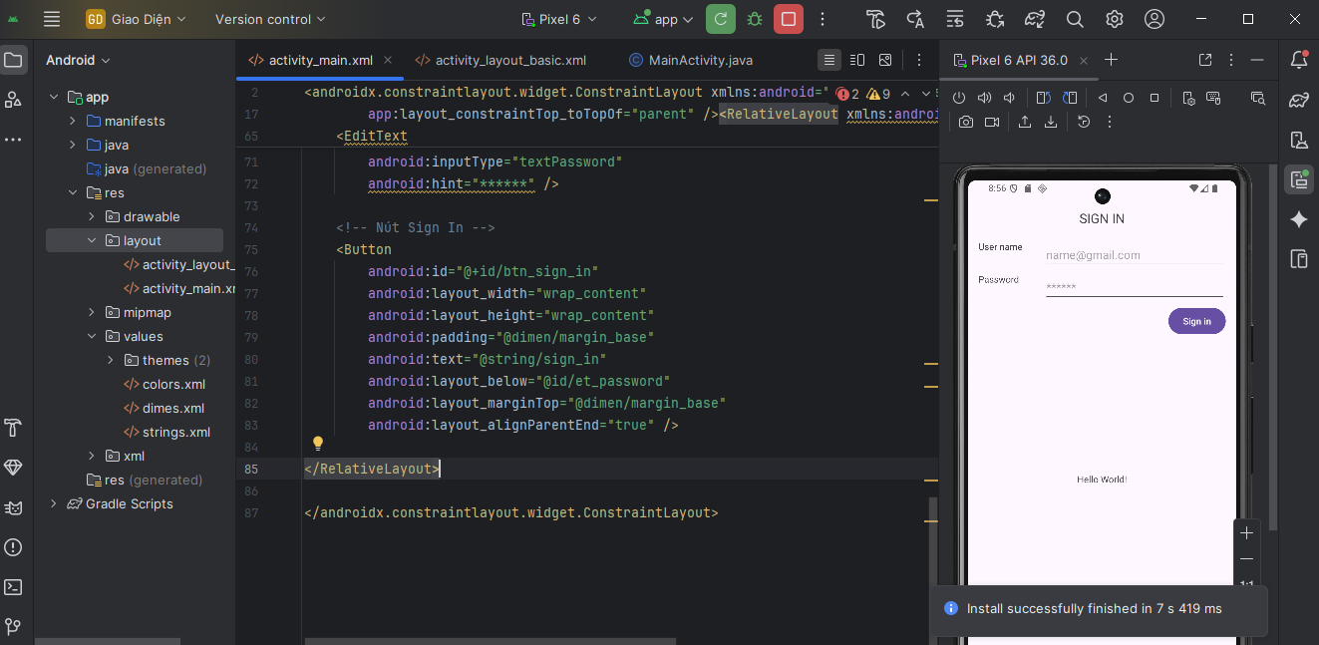

Layout 2 : LinearLayout

Color .xml

<resources>

<color name="color0">#000000</color> <color name="color1">#FF0000</color> <color name="color2">#00FF00</color> <color name="color3">#0000FF</color> <color name="color4">#FFFF00</color> <color name="color5">#FF00FF</color> <color name="color6">#00FFFF</color> <color name="color7">#FFFFFF</color> </resources>

Activity .xml

<?xml version="1.0" encoding="utf-8"?>

<LinearLayout xmlns:android="http://schemas.android.com/apk/res/android"

xmlns:tools="http://schemas.android.com/tools"

android:layout_width="match_parent"

android:layout_height="match_parent"

android:orientation="vertical"

tools:context="vn.edu.uit.lab01_2b.MainActivity">

<LinearLayout

android:layout_width="match_parent"

android:layout_height="0dp"

android:layout_weight="1"

android:background="@color/color0"

android:orientation="horizontal"></LinearLayout>

<LinearLayout

android:layout_width="match_parent"

android:layout_height="0dp"

android:layout_weight="2"

android:orientation="horizontal">

<LinearLayout

android:layout_width="0dp"

android:layout_height="match_parent"

android:layout_weight="1"

android:orientation="vertical">

<LinearLayout

android:layout_width="match_parent"

android:layout_height="0dp"

android:layout_weight="1"

android:background="@color/color2"

android:orientation="horizontal"></LinearLayout>

<LinearLayout

android:layout_width="match_parent"

android:layout_height="0dp"

android:layout_weight="1"

android:background="@color/color3"

android:orientation="horizontal"></LinearLayout>

</LinearLayout>

<LinearLayout

android:layout_width="0dp"

android:layout_height="match_parent"

android:layout_weight="1"

android:background="@color/color1"

android:orientation="vertical"></LinearLayout>

</LinearLayout>

</LinearLayout>

Kết quả có được :

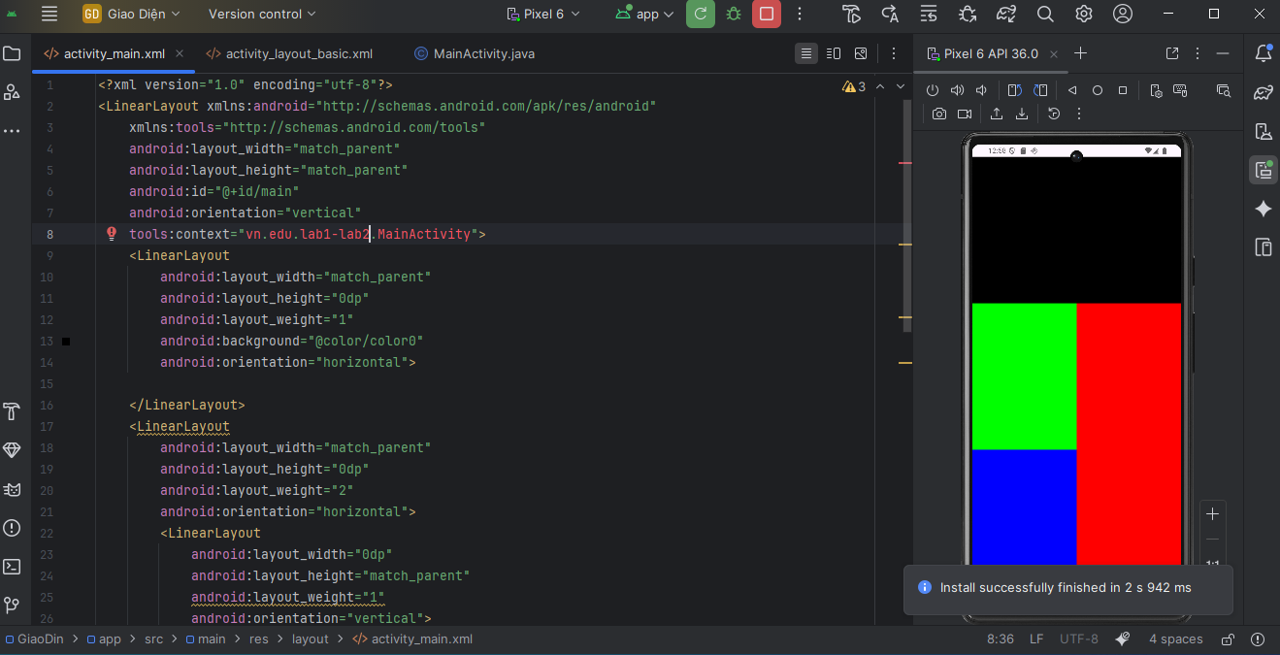

Layout 3 : calculator

Activity.xml

<?xml version="1.0" encoding="utf-8"?>  
<LinearLayout xmlns:android="http://schemas.android.com/apk/res/android"  
 android:layout_width="match_parent"  
 android:layout_height="match_parent"  
 android:id="@+id/main"  
 android:orientation="vertical"  
 android:padding="16dp"  
 android:background="#121212">  
  
 <!-- Màn hình hiển thị kết quả -->  
 <TextView  
 android:id="@+id/txtResult"  
 android:layout_width="380dp"  
 android:layout_height="100dp"  
 android:layout_margin="10dp"  
 android:layout_marginTop="100dp"  
 android:layout_marginBottom="12dp"  
 android:background="@color/color3"  
 android:gravity="end|center_vertical"  
 android:padding="10dp"  
 android:text="0"  
 android:textColor="@color/color6"  
 android:textSize="34sp" />  
  
 <!-- Bàn phím số và phép toán -->  
 <GridLayout  
 android:layout_width="match_parent"  
 android:layout_height="wrap_content"  
 android:rowCount="5"  
 android:columnCount="4"  
 android:alignmentMode="alignMargins"  
 android:columnOrderPreserved="false"  
 android:layout_marginTop="120dp"  
 android:layout_marginBottom="20dp">  
  
 <!-- Hàng 1 -->  
 <Button android:text="C" style="@style/CalcButton" />  
 <Button android:text="%" style="@style/CalcButton" />  
 <Button android:text="÷" style="@style/CalcButtonOrange" />  
 <Button android:text="⌫" style="@style/CalcButton" />  
  
 <!-- Hàng 2 -->  
 <Button android:text="7" style="@style/CalcButton" />  
 <Button android:text="8" style="@style/CalcButton" />  
 <Button android:text="9" style="@style/CalcButton" />  
 <Button android:text="×" style="@style/CalcButtonOrange" />  
  
 <!-- Hàng 3 -->  
 <Button android:text="4" style="@style/CalcButton" />  
 <Button android:text="5" style="@style/CalcButton" />  
 <Button android:text="6" style="@style/CalcButton" />  
 <Button android:text="−" style="@style/CalcButtonOrange" />  
  
 <!-- Hàng 4 -->  
 <Button android:text="1" style="@style/CalcButton" />  
 <Button android:text="2" style="@style/CalcButton" />  
 <Button android:text="3" style="@style/CalcButton" />  
 <Button android:text="+" style="@style/CalcButtonOrange" />  
  
 <!-- Hàng 5 -->  
 <Button android:text="0" style="@style/CalcButton"  
 android:layout_columnSpan="2"  
 android:layout_gravity="fill" />  
 <Button android:text="." style="@style/CalcButton" />  
 <Button android:text="=" style="@style/CalcButtonOrange" />  
 </GridLayout>  
</LinearLayout>

Styles.xml

<?xml version="1.0" encoding="utf-8"?>  
<resources>  
 <!-- Style nút mặc định -->  
 <style name="CalcButton">  
 <item name="android:layout_width">0dp</item>  
 <item name="android:layout_height">80dp</item>  
 <item name="android:layout_columnWeight">1</item>  
 <item name="android:layout_margin">4dp</item>  
 <item name="android:background">#333333</item>  
 <item name="android:textColor">#FFFFFF</item>  
 <item name="android:textSize">20sp</item>  
 </style>  
  
 <!-- Style nút phép toán -->  
 <style name="CalcButtonOrange" parent="CalcButton">  
 <item name="android:background">#FF9500</item>  
 <item name="android:textColor">#FFFFFF</item>  
 </style>  
</resources>

Kết quả có được :

